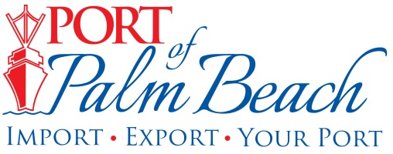
Media Contact
Yaremi Farinas
yfarinas@portofpalmbeach.com
561-383-4138

Donated supplies shipped from Port of Palm Beach

Riviera Beach, Florida – October 15, 2019 – In the past month, the Green Turtle Cay Foundation has shipped roughly three million pounds of donated supplies from the Port of Palm Beach.
“A lot of the people in the islands are experiencing a degree of PTSD so that is why we have been getting over there to bring in relief to kind of calm them and show them progress, show them there is a light at the end of the tunnel,” said Sarah Ann Showell, whose family owns a resort in Green Turtle Cay.
There have been at least three relief voyages to Green Turtle Cay from the Port of Palm Beach, thanks to the foundation and port tenant Gulfstream Line/ Heavy Lift Services Inc.
Some of the relief items shipped into the island include, duct tape, peel and stick roof, generators, chainsaws, air mattresses, mosquito netting, hygiene products, construction material and much more.

About Port of Palm Beach
Located in Riviera Beach, the Port of Palm Beach is a full-service, diversified port, offering cruise and cargo services to more than 30 onsite tenants and users. At 162 acres, the Port’s efficiency is unparalleled, processing more than $7 billion in commodities, 2.5 million tons of cargo, and 500,000 cruise passengers annually. As one of the largest employers in Palm Beach County, the Port of Palm Beach and its tenants employ more than 2,850 people. Through the contribution of more than $185 million in business revenue and $17.5 million in tenant-contributed state and local annual tax revenue, the Port of Palm Beach is a large economic engine in South Florida. For more information, visit www.portofpalmbeach.com.

